 | 20.1.6 Editors - NLA Editor - Edit Menu
Table of content
NLA Editor - Edit Menu 2
Transform 2
Grab/Move 2
Last Operator Move 2
Move X, Y Z 2
Orientation 2
Mirror Editing 2
Proportional editing 2
Extend 3
Last Operator Transform 3
Values X, Y Z, W 3
Axis 3
Orientation 3
Mirror Editing 3
Proportional editing 3
Scale 3
Last Operator Resize 3
Angle 3
Axis 3
Orientation 3
Mirror Editing 4
Proportional editing 4
Snap 4
Bake Action 4
Duplicate 4
Linked Duplicate 4
Split Strips 4
Rename 4
Delete Strips 5
Delete Tracks 5
Apply Scale 5
Clear Scale 5
Sync Action Length 5
Make Single User 5
Swap Strips 5
Move strips up 5
Move Strips down 5
Track Ordering 5
Remove Empty Animation Data 5
Tweak Isolated Action 6
Tweak Action (Full Stack) 6
Tweak Action (Lower Stack) 6

NLA Editor - Edit Menu
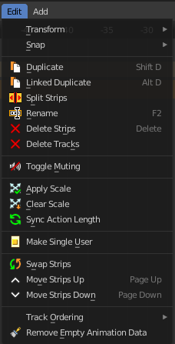
This menu contains functionality to manage the keyframes.

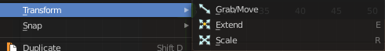
Transform

Grab/Move
Moves the selected keyframe(s).

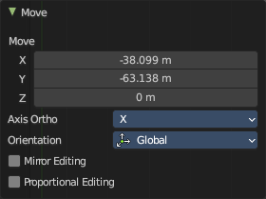
Last Operator Move

Move X, Y Z
The position. Attention, the actual world orientation and rotation does not matter here. It always starts with a value of zero, and moves relative to this zero then. For the actual location values have a look in the sidebar in the transform panel.

Orientation

The widget can have different orientations. The menu items should be self explaining.

Mirror Editing
Enable Mirror editing

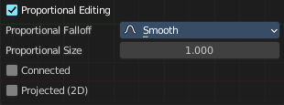
Proportional editing
Proportional editing is not available for this mode.

Extend
Moves the last keyframes of the selection.

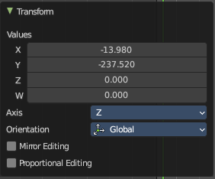
Last Operator Transform

Values X, Y Z, W
The new position.

Axis
Which axis to transform.

Orientation
The widget can have different orientations. The menu items should be self explaining.

Mirror Editing
Enable Mirror editing

Proportional editing
Proportional editing is not available for this mode.

Scale
Scales the selected keyframes. You need to have more than one keyframe selected.

Last Operator Resize

Angle
The rotation. Attention, the actual world orientation and rotation does not matter here. It always starts with a value of zero, and rotates relative to this zero then. For the actual rotation values have a look in the sidebar in the transform panel.

Axis
Which axis to rotate.

Orientation
The widget can have different orientations. The menu items should be self explaining.

Mirror Editing
Enable Mirror editing

Proportional editing
Proportional editing is not available for this mode.

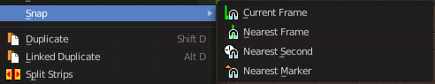
Snap
Snaps the selected keyframes by the chosen method.

Bake Action
Bakes all selected objects locations/scale/rotation animations to an action.
To use this operator, a dialogue will prompt to define the parameters before applying the bake action.
The final animation of the selected objects or bones is computed with all modifiers, drivers, and constraints applied with keyed results per frame step in a range.

Duplicate
Duplicate selected keyframes.

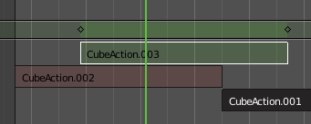
Linked Duplicate
Duplicates the selected strip(s), and creates a new track for the duplicates. This copy is linked to the original action strip. Modifications at the original will also affect the linked action strip.
Linked strips are visually different from normal strips. And when you start to modify the linked duplicate, then the original strip will turn red.

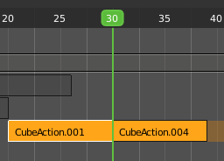
Split Strips
Splits the selected strip(s) at the marker position.

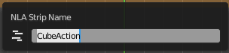
Rename
Allows you to rename the current NLA strip. The operator calls a rename popup.

Delete Strips
Deletes the selected strips.

Delete Tracks
Deletes the selected track(s).
Toggle Muting
Disables the selected action clip. Be careful, there is no visual hint if the clip is muted or not.

Apply Scale
Applies the current scale of the clips to be 1.

Clear Scale
Resets the scale of the clip back to 1.

Sync Action Length
Synchronize the length of the action with the keyframe length used in the strip.

Make Single User
You can create linked duplicates. Make single user makes them into individual clips.

Swap Strips
Swaps the selected strips.

Move strips up
Moves the selected action strips upwards into the next track.

Move Strips down
Moves the selected action strips downwards into the next track.

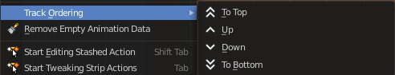
Track Ordering
Order the tracks.

Remove Empty Animation Data
Removes action clips that are empty.

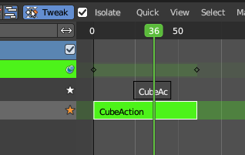
Tweak Isolated Action
Allows you to edit the keyframe data within the Action strip while isolating the active Action clip from all tracks. This mode allows you to insert keyframes into the isolated Action clip.
This tweak mode is similar to the one in the header with the Isolate toggle turned on. This tweak mode in the header does not preserve the pose of the full stack.
Leaving the Tweak mode is for all methods evaluated in the header.

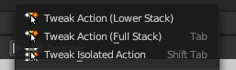
Tweak Action (Full Stack)
Allows you to edit the keyframe data within the Action strip while evaluating all Action clips in the NLA stack. This mode allows you to insert keyframes and preserve the pose that you visually key while all strips are evaluating.
This tweak mode is also accessed from the “tweak” button in the header when the isolate checkbox is disabled.
Leaving the Tweak mode is for all methods evaluated in the header.

Tweak Action (Lower Stack)
Allows you to edit the keyframe data within the Action strip while evaluating only Action clips located below the active track in the NLA stack. This mutes all tracks above the active Action clip track and only evaluates tracks below.
This tweak mode is similar to the one in the header but it allows you to insert keyframes and preserve the pose that you visually keyed while lower strips are evaluating only.
Leaving the Tweak mode is for all methods evaluated in the header.

